**DECLARATION**

I, **G. KAVIYARASAN** declare that the project work entailed **“DIRECT BUYING AND SELLING AGRICULTURAL PRODUCTS”** submitted to Kongunadu Arts and Science College (Autonomous), Coimbatore affiliated to Bharathiyar University, in partial fulfillment of the requirements for the award of the Degree of Bachelor of Computer Applications is a record of original work done by me under the valuable guidance of **LEENA IMMACULATE** Professor in Computer Applications (UG), Kongunadu Arts and Science College (Autonomous), Coimbatore.

Signature of the Candidate

**G. KAVIYARASAN**

**Place: Coimbatore**

**Date:**

**CONTENTS**

**S.NO TITLE PAGE.NO**

1 INTRODUCTION

* 1. ABOUT THE PROJECT
  2. MODULE DESCRIPTION

1. SYSTEM SPECIFICATION
   1. HARDWARE REQUIREMENT
   2. SOFTWARE REQUIREMENT
   3. ABOUT THE SOFTWARE
2. SYSTEM STUDY
   1. EXISTING SYSTEM
   2. PROPOSED SYSTEM
3. ` SYSTEM DESIGN
   1. DATA FLOW DIAGRAM
   2. DATABASE DESIGN
   3. INPUT DESIGN
   4. OUTPUT DESIGN
4. SYSTEM TESTING AND IMPLEMENTATION
   1. SYSTEM TESTING
   2. SYSTEM IMPLEMENTATION
5. CONCLUSION
6. SCOPE FOR FUTURE ENHANCEMENT

**SYNOPSIS**

Farmer corner is a website which helps buyer to get products directly from the farmer. Farmer can login into the website with a separate login ID’s and passwords. In this website the products are posted by the farmer. The product is posted with full details of its which conveys the state of the product, quantity of products available and the location of the product where it was harvested by the farmer. By posting the pictures and cost of the products the consumer could easily access the farmer. They can also add the production cost of the products and that could be farmers choice. For those farmers who don’t have access to the internet facility could contact through phone call and our team could able to arrange the facilities to them with the help of nearby browsing centers.

In this System, there was no third party to interrupt for buying and selling. This helps both farmer and buyer in many ways. Without the interference of the third-party traders the farmers can reach the buyers directly and sell the products. This is a open source website. Even This System does not charge for the process of helping farmers and buyers. Donation can be done when farmer or buyer gets satisfied by this website.

Buyers can visit the website by logging in website and buy the products trust with the help of checking the quality of the product. When there was no Interference with third party, buyer can get products with low cost than getting it from a third party. The quality of the product also be verified on the current place itself.

**1.2 ABOUT THE PROJECT**

Direct Buying and Selling Agricultural Products helps in improvement of dealing of buyer and farmer. Farmer corner is a website which helps buyer to get products directly from the farmer. Farmer can login into the website with a separate login ID’s and passwords. In this website the products are posted by the farmer. The product is posted with full details of its which conveys the state of the product, quantity of products available and the location of the product where it was harvested by the farmer. By posting the pictures and cost of the products the consumer could easily access the farmer. They can also add the production cost of the products and that could be farmers choice. For those farmers who don’t have access to the internet facility could contact through phone call and our team could able to arrange the facilities to them with the help of nearby browsing centers.

In this System, there was no third party to interrupt for buying and selling. This helps both farmer and buyer in many ways. Without the interference of the third-party traders the farmers can reach the buyers directly and sell the products. This is an open-source website. Even This System does not charge for the process of helping farmers and buyers. Donation can be done when farmer or buyer gets satisfied by this website.

Buyers can visit the website by logging in website and buy the products trust with the help of checking the quality of the product. When there was no Interference with third party, buyer can get products with low cost than getting it from a third party. The quality of the product also be verified on the current place itself. Buyer has demand of buying products they buy products with large amount in a low cost.

**MODULE DESCRIPTION**

* FARMER LOGIN
* USER LOGIN
* PRODUCTS
* FEEDBACK

**FARMER LOGIN**

The farmer can register into this website when he/she was new to it. After they can login to the website and post the details of the product, they have with them. The details of the products are mentioned with location, contact details, quality and quantity of the products available.

**USER LOGIN**

The user can register into this website when he/she was new to it. After they can login to the website and can verify the products posted by the farmer. And can buy the product needed. The buyer will be travel to the exact location of the product cultivated or to a common place which was comfort for the both buyer and farmer.

**PRODUCT**

Agricultural products like fruits and vegetables are posted by the farmer. The products are posted with details for the guidance for the buyer. Where buyer verify the product, he/she need to buy.

**FEEDBACK**

The buyer and user both can review their comments in the feedback form. This helps us to maintain the corrections in the website.

**CHAPTER 2**

**SYSTEM STUDY AND ANALYSIS**

**2.1 EXISTING SYSTEM**

There was a website and application named “vidhai”. “vidhai” is a retail-focused store offering food and related consumables produced from organic farming methods and certified organic according to organic farming standards. They are the connections between the farmer and buyer. This is also be like flipkart, amazon but only with organic products. In this system includes door delivery where your products will be in your doorstep.

**2.1.1 DRAWBACKS OF EXISTING SYSTEM**

* The cost of the product is higher than the cost of product when it was in the hand of farmer.
* It takes time to get the products from the website.
* They include delivery charges when less amount of product bought by user.
* Products can’t be verified and it can only view when order was in hand.
* This includes third party there will be no trust on the product state.

**2.2 PROPOSED SYSTEM**

“FARMER CORNER” is an open-source website. The buyer gets the product from a well know farmer nearby. This system makes more comfortable for the buyers. Here we post only agricultural products like fruits and vegetables. The products are posted with the photos, amount of the product, location of the product and farmer’s contact details. Location of the product Consumer get the products on the spot of the product yielded. From this the farmer can view the state of it and verify the product. He can judge the worth of the product and can be bought with the low cost. If there was an error or some queries, the farmer/user contact the admin with the below mentioned contacts at the end of the home page. This System was most helpful for the farmer and User.

**2.2.1 ADVANTAGES OF PROPOSED SYSTEM**

* This website doesn’t include third parties interfere.
* The product state can be verified by the user on the location of the product yielded.
* Cost of the product will be decreased for the buyer, when direct purchasing between farmer and buyer.
* Product will be sold little higher amount, which even helps to gain more for farmer.
* By the help of the location included by the farmer, buyer need not to be travelled for long distance for buying products.
* User/Buyer can check the quantity of the product and he/she can satisfy the needy.

**CHAPTER 3**

**SYSTEM CONFIGURATION**

**3.1 HARDWARE CONFIGURATION**

**Processor : Any processor above 2 GHz**

**Ram : 2 GB**

**Hard Disk : 100 GB**

**3.2 SOFTWARE CONFIGURATION**

**Language : HTML**

**Technologies : CSS, Java Script, Bootstrap**

**Backend : My SQL**

**Web Server : Apache**

**3.3 SOFTWARE FEATUERES**

**HTML (HyperText Markup Language)**

**HTML** stands for HyperText Markup Language. It is used to design web pages using a markup language. HTML is the combination of Hypertext and Markup language. Hypertext defines the link between the web pages. A markup language is used to define the text document within tag which defines the structure of web pages. This language is used to annotate (make notes for the computer) text so that a machine can understand it and manipulate text accordingly. Most markup languages (e.g., HTML) are human-readable. The language uses tags to define what manipulation has to be done on the text.

HTML is a markup language used by the browser to manipulate text, images, and other content, in order to display it in the required format. HTML was created by Tim Berners-Lee in 1991. The first-ever version of HTML was HTML 1.0, but the first standard version was HTML 2.0, published in 1995.

**ADVANTAGE OF HTML**

* HTML is Easy to Learn and Use HTML is very easy to learn and understand.
* HTML is Free One of the biggest advantages of HTML is that it is free of cost and there is no need to purchase specific software.
* HTML is supported by all Browsers Almost all the browsers around the globe are supported by HTML.
* HTML is the Friendliest Search Engine HTML is one of the friendliest search engines in comparison to all the programming languages available in the market (Search Engine).
* HTML is Simple to Edit HTML is very easy to edit as there is no need to have a special interface or platform to edit it.
* HTML can Integrate Easily with Other Languages HTML can be easily integrated with multiple languages and does not create any issues in it.
* HTML is Lightweight HTML is lightweight language. It has a high signal to noise ratio as compared to other forms of communication.
* HTML is Basic of all Programming Languages For the programmer to be either frontend or backend developer, one must have knowledge of HTML as it is the basic language.
* Display Changes Instantly One of the biggest advantages of HTML is that one can see the changes instantly just by saving it and reload the previous HTML page.
* HTML is User-Friendly.

**CSS (Cascading Style Sheet)**

Cascading Style Sheets, fondly referred to as CSS, is a simple design language intended to simplify the process of making web pages presentable.

CSS handles the look and feel part of a web page. Using CSS, you can control the color of the text, the style of fonts, the spacing between paragraphs, how columns are sized and laid out, what background images or colours are used, layout designs, variations in display for different devices and screen sizes as well as a variety of other effects.

CSS is easy to learn and understand but it provides powerful control over the presentation of an HTML document. Most commonly, CSS is combined with the markup languages HTML or XHTML.

**ADVANTAGES of CSS**

* **CSS saves time** − You can write CSS once and then reuse same sheet in multiple HTML pages. You can define a style for each HTML element and apply it to as many Web pages as you want.
* **Pages load faster** − If you are using CSS, you do not need to write HTML tag attributes every time. Just write one CSS rule of a tag and apply it to all the occurrences of that tag. So, less code means faster download times.
* **Easy maintenance** − To make a global change, simply change the style, and all elements in all the web pages will be updated automatically.
* **Superior styles to HTML** − CSS have a much wider array of attributes than HTML, so you can give a far better look to your HTML page in comparison to HTML attributes.
* **Multiple Device Compatibility** − Style sheets allow content to be optimized for more than one type of device. By using the same HTML document, different versions of a website can be presented for handheld devices such as PDAs and cell phones or for printing.
* **Global web standards** − Now HTML attributes are being deprecated and it is being recommended to use CSS. So, it’s a good idea to start using CSS in all the HTML pages to make them compatible to future browsers.

**JAVASCRIPT**

JavaScript is a dynamic computer programming language. It is lightweight and most commonly used as a part of web pages, whose implementations allow client-side script to interact with the user and make dynamic pages. It is an interpreted programming language with object-oriented capabilities.

JavaScript was first known as **Live Script,** but Netscape changed its name to JavaScript, possibly because of the excitement being generated by Java. JavaScript made its first appearance in Netscape 2.0 in 1995 with the name **Live Script**. The general-purpose core of the language has been embedded in Netscape, Internet Explorer, and other web browsers.

The [ECMA-262 Specification](http://www.ecma-international.org/publications/index.html) defined a standard version of the core JavaScript language.

* JavaScript is a lightweight, interpreted programming language.
* Designed for creating network-centric applications.
* Complementary to and integrated with Java.
* Complementary to and integrated with HTML.
* Open and cross-platform

## CLIENT-SIDE JAVASCRIPT

Client-side JavaScript is the most common form of the language. The script should be included in or referenced by an HTML document for the code to be interpreted by the browser.

It means that a web page need not be a static HTML, but can include programs that interact with the user, control the browser, and dynamically create HTML content.

The JavaScript client-side mechanism provides many advantages over traditional CGI server-side scripts. For example, you might use JavaScript to check if the user has entered a valid e-mail address in a form field.

The JavaScript code is executed when the user submits the form, and only if all the entries are valid, they would be submitted to the Web Server.

JavaScript can be used to trap user-initiated events such as button clicks, link navigation, and other actions that the user initiates explicitly or implicitly.

## ADVANTAGES OF JAVASCRIPT

The merits of using JavaScript are −

* **Less server interaction** − You can validate user input before sending the page off to the server. This saves server traffic, which means less load on your server.
* **Immediate feedback to the visitors** − They don't have to wait for a page reload to see if they have forgotten to enter something.
* **Increased interactivity** − You can create interfaces that react when the user hovers over them with a mouse or activates them via the keyboard.
* **Richer interfaces** − You can use JavaScript to include such items as drag-and-drop components and sliders to give a Rich Interface to your site visitors.

## LIMITATIONS OF JAVASCRIPT

We cannot treat JavaScript as a full-fledged programming language. It lacks the following important features −

* Client-side JavaScript does not allow the reading or writing of files. This has been kept for security reason.
* JavaScript cannot be used for networking applications because there is no such support available.
* JavaScript doesn't have any multi-threading or multiprocessor capabilities.

Once again, JavaScript is a lightweight, interpreted programming language that allows you to build interactivity into otherwise static HTML pages.

## JAVASCRIPT DEVELOPMENT TOOLS

One of major strengths of JavaScript is that it does not require expensive development tools. You can start with a simple text editor such as Notepad. Since it is an interpreted language inside the context of a web browser, you don't even need to buy a compiler.

To make our life simpler, various vendors have come up with very nice JavaScript editing tools. Some of them are listed here −

* **Microsoft FrontPage** − Microsoft has developed a popular HTML editor called FrontPage. FrontPage also provides web developers with a number of JavaScript tools to assist in the creation of interactive websites.
* **Macromedia Dreamweaver MX** − Macromedia Dreamweaver MX is a very popular HTML and JavaScript editor in the professional web development crowd. It provides several handy prebuilt JavaScript components, integrates well with databases, and conforms to new standards such as XHTML and XML.
* **Macromedia Home Site 5** – Home Site 5 is a well-liked HTML and JavaScript editor from Macromedia that can be used to manage personal websites effectively.

**BOOTSTRAP**

Bootstrap is a**free and open-source web development framework**. It’s designed to ease the web development process of responsive, mobile-first websites by providing a collection of syntax for template designs. In other words, Bootstrap helps web developers build websites faster as they don’t need to worry about basic commands and functions. It is the most popular front-end framework in the recent time. It is sleek, intuitive, and powerful mobile first front-end framework for faster and easier web development. It uses HTML, CSS and JavaScript. This tutorial will teach you the basics of Bootstrap Framework using which you can create web projects with ease. The tutorial is divided into sections such as Bootstrap Basic Structure, Bootstrap CSS, Bootstrap Layout Components and Bootstrap Plugins. Each of these sections contain related topics with simple and useful examples.

## APPLICATIONS OF BOOTSTRAP

## Scaffolding − Bootstrap provides a basic structure with Grid System, link styles, and background. This is covered in detail in the section Bootstrap Basic Structure

* **CSS** − Bootstrap comes with the feature of global CSS settings, fundamental HTML elements styled and enhanced with extensible classes, and an advanced grid system. This is covered in detail in the section **Bootstrap with CSS**.
* **Components** − Bootstrap contains over a dozen reusable components built to provide iconography, dropdowns, navigation, alerts, pop-overs, and much more. This is covered in detail in the section **Layout Components**.
* **JavaScript Plugins** − Bootstrap contains over a dozen custom jQuery plugins. You can easily include them all, or one by one. This is covered in details in the section **Bootstrap Plugins**.
* **Customize** − You can customize Bootstrap's components, LESS variables, and jQuery plugins to get your very own version.

**PHP (Hypertext Preprocessor)**

The PHP Hypertext Preprocessor (PHP) is a programming language that allows web developers to create dynamic content that interacts with databases. PHP is basically used for developing web-based software applications. This tutorial helps you to build your base with PHP.

**ADVANTAGES OF PHP**

* PHP is a recursive acronym for "PHP: Hypertext Preprocessor".
* PHP is a server-side scripting language that is embedded in HTML. It is used to manage dynamic content, databases, session tracking, even build entire e-commerce sites.
* It is integrated with a number of popular databases, including MySQL, PostgreSQL, Oracle, Sybase, Informix, and Microsoft SQL Server.
* PHP is pleasingly zippy in its execution, especially when compiled as an Apache module on the Unix side. The MySQL server, once started, executes even very complex queries with huge result sets in record-setting time.
* PHP supports a large number of major protocols such as POP3, IMAP, and LDAP. PHP4 added support for Java and distributed object architectures (COM and CORBA), making n-tier development a possibility for the first time.
* PHP is forgiving: PHP language tries to be as forgiving as possible.
* PHP Syntax is C-Like.

**CHARACTERISTICS OF PHP**

Five important characteristics make PHP's practical nature possible −

* Simplicity
* Efficiency
* Security
* Flexibility
* Familiarity

**SQL (Structured Query language)**

SQL is a language to operate databases; it includes database creation, deletion, fetching rows, modifying rows, etc. SQL is an ANSI (American National Standards Institute) standard language, but there are many different versions of the SQL language. SQL is Structured Query Language, which is a computer language for storing, manipulating and retrieving data stored in a relational database SQL is the standard language for Relational Database System. All the Relational Database Management Systems (RDMS) like MySQL, MS Access, Oracle, Sybase, Informix, Postgres and SQL Server use SQL as their standard database language. Also, they are using different dialects, such as −

* MS SQL Server using T-SQL,
* Oracle using PL/SQL,
* MS Access version of SQL is called JET SQL (native format) etc.

**ADVANTAGES OF SQL**

* Allows users to access data in the relational database management systems.
* Allows users to describe the data.
* Allows users to define the data in a database and manipulate that data.
* Allows to embed within other languages using SQL modules, libraries & pre-compilers.
* Allows users to create and drop databases and tables.
* Allows users to create view, stored procedure, functions in a database.
* Allows users to set permissions on tables, procedures and views.

**SQL PROCESS**

When you are executing an SQL command for any RDBMS, the system determines the best way to carry out your request and SQL engine figures out how to interpret the task.

There are various components included in this process.

These components are −

* Query Dispatcher
* Optimization Engines
* Classic Query Engine
* SQL Query Engine, etc.

A classic query engine handles all the non-SQL queries, but a SQL query engine won't handle logical files.

**CONNECTING TO A DATABASE**

In order to connect to a database, you need to perform some initialization first. XAMPP should be installed in the system. The entire Frontend works should be in the htdocs folder which is located in the XAMPP folder. Code entered in the .php formats. It can be run by copying the location of the file and paste it to the localhost server. In browser search “Localhost\ file location”.

**DATA FLOW DIAGRAM**

**LEVEL 0**

Login/ Registration

process

Output

**LEVEL 2**

Authentication

Farmer login

Output

Authentication

User Login

DATABASE

**CHAPTER 7**

**SCOPE FOR FUTURE ENHANCEMENT**

In this system we can add farming related items like seeds, plants, organic fertilizers, and species, etc..,. This Website can reach to a good level. Products are more upgraded with new items.

**HOME PAGE**

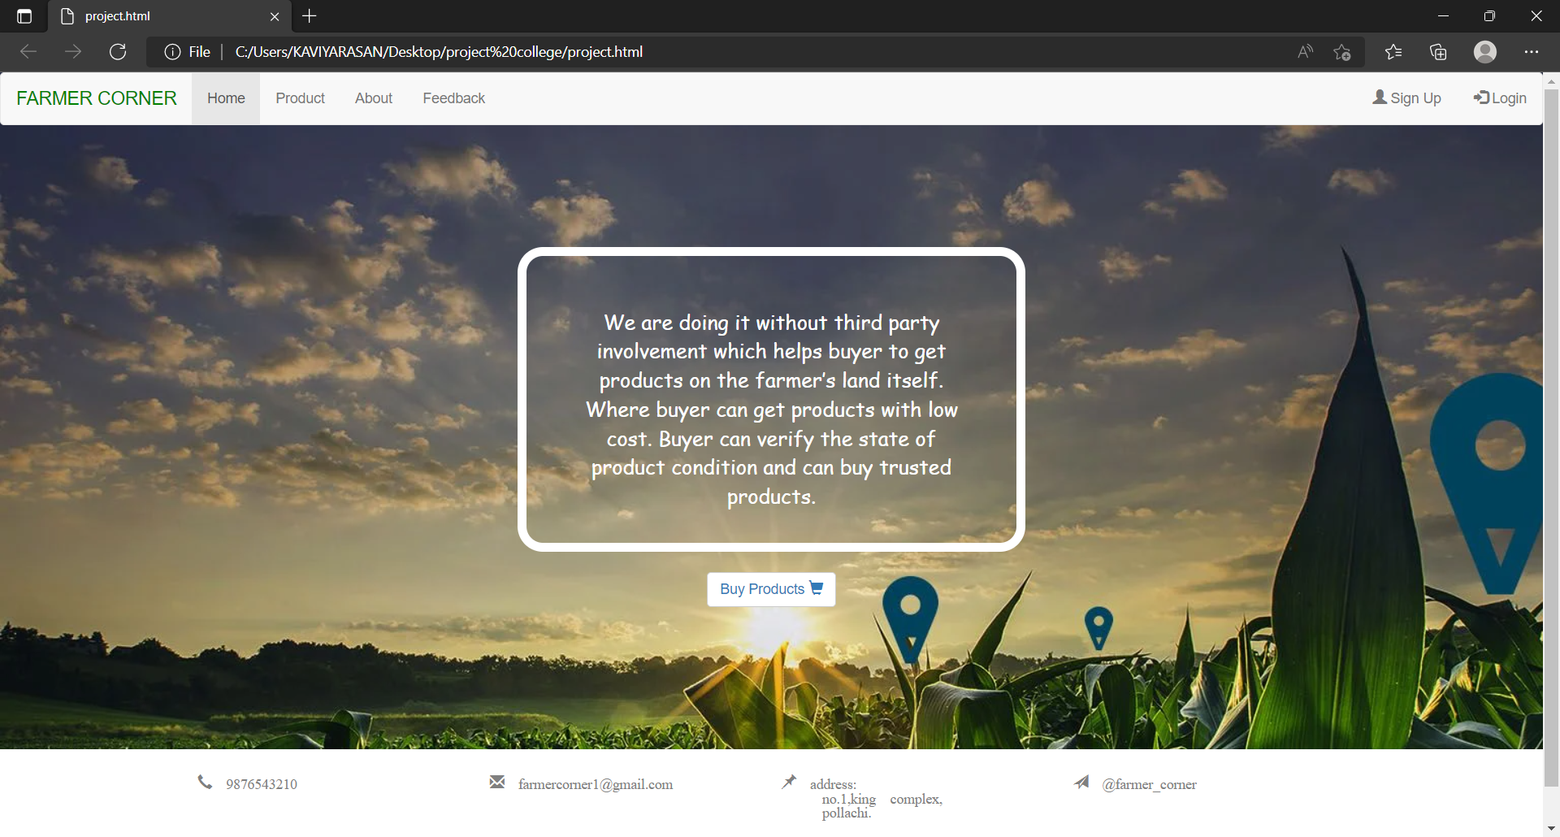

**PRODUCT PAGE**

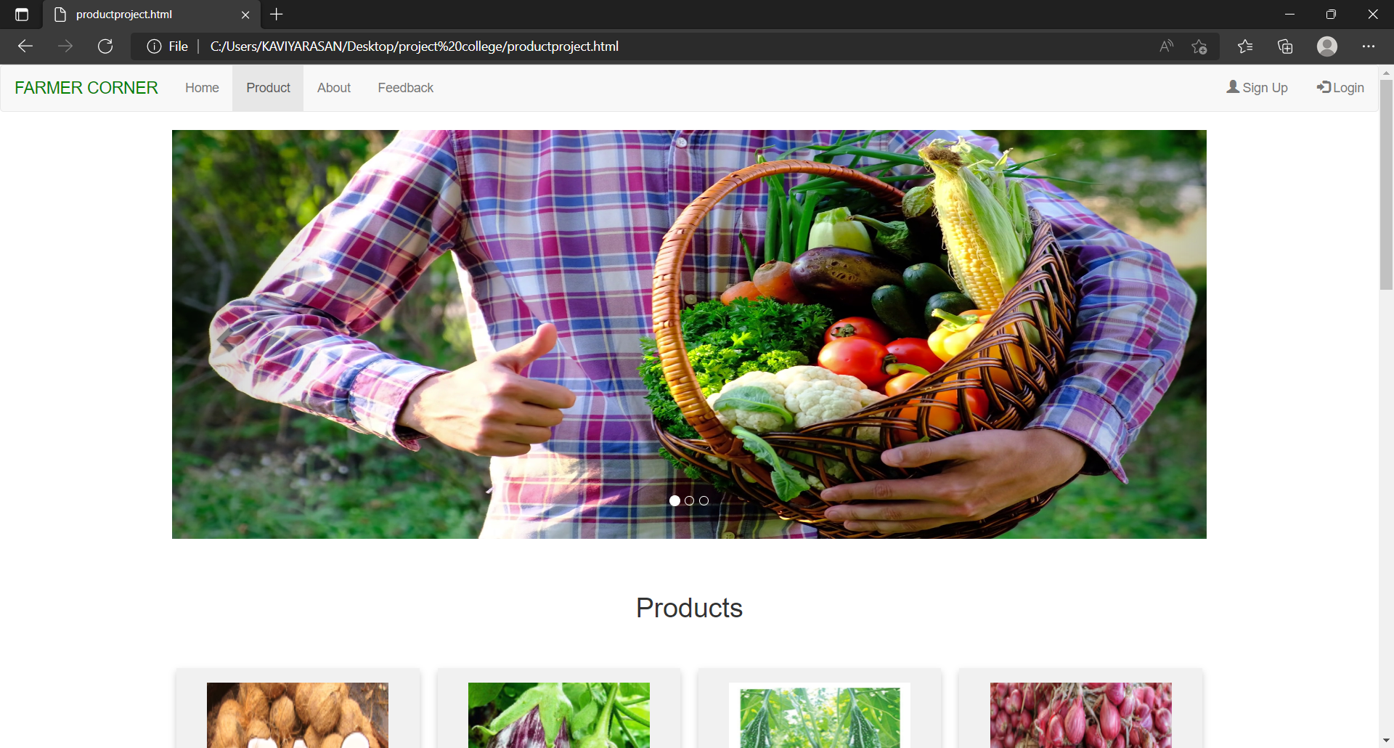

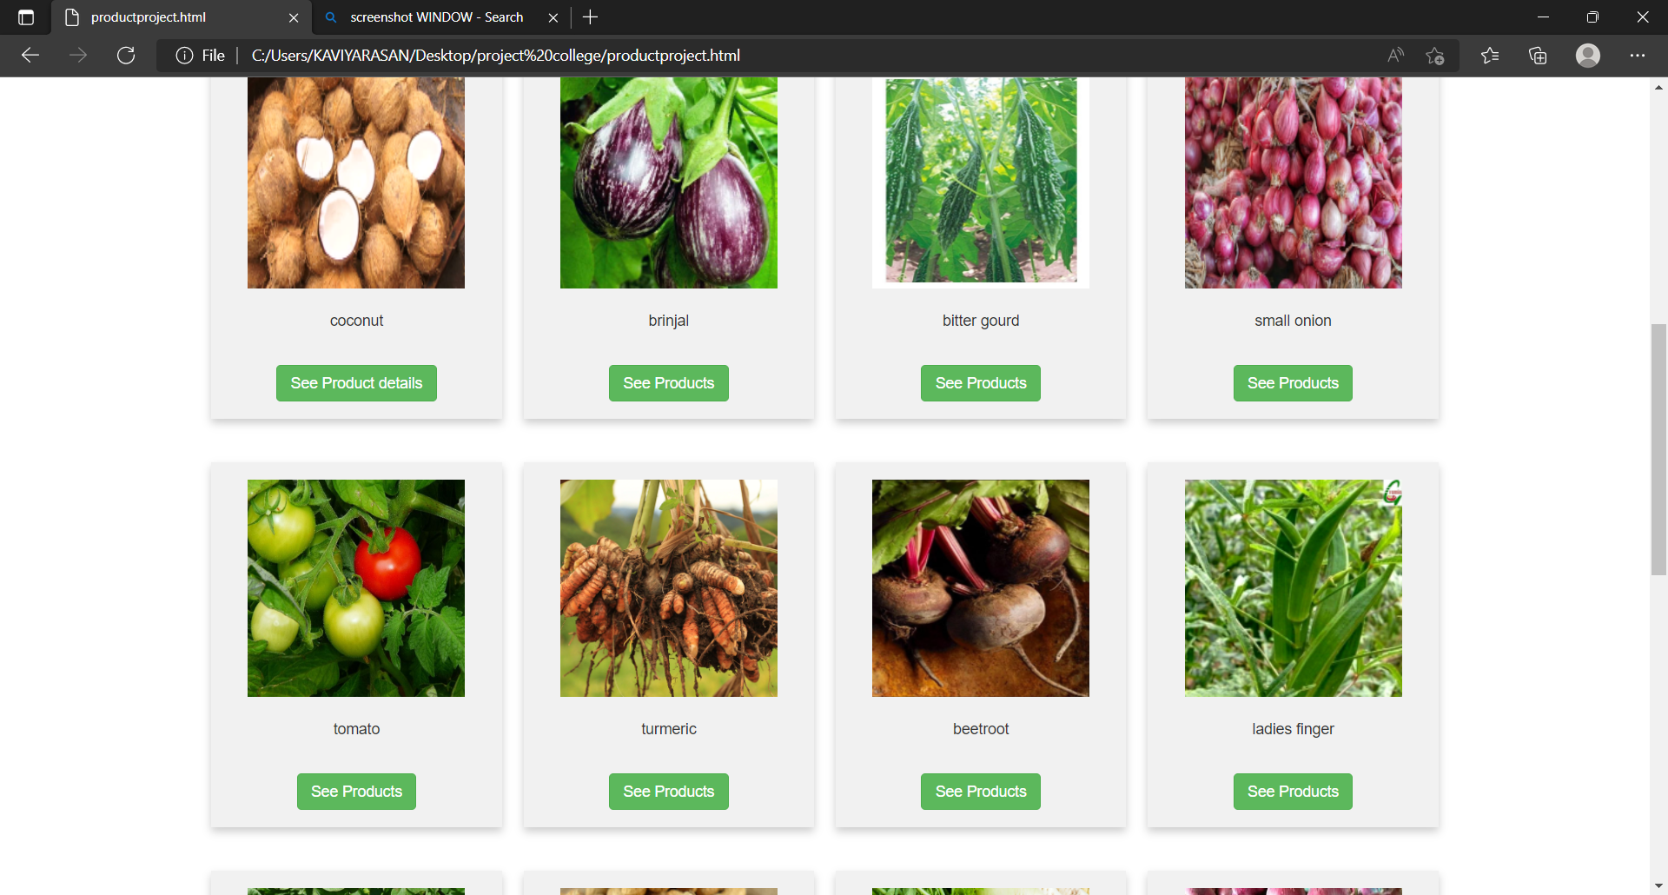

**ABOUT PAGE**

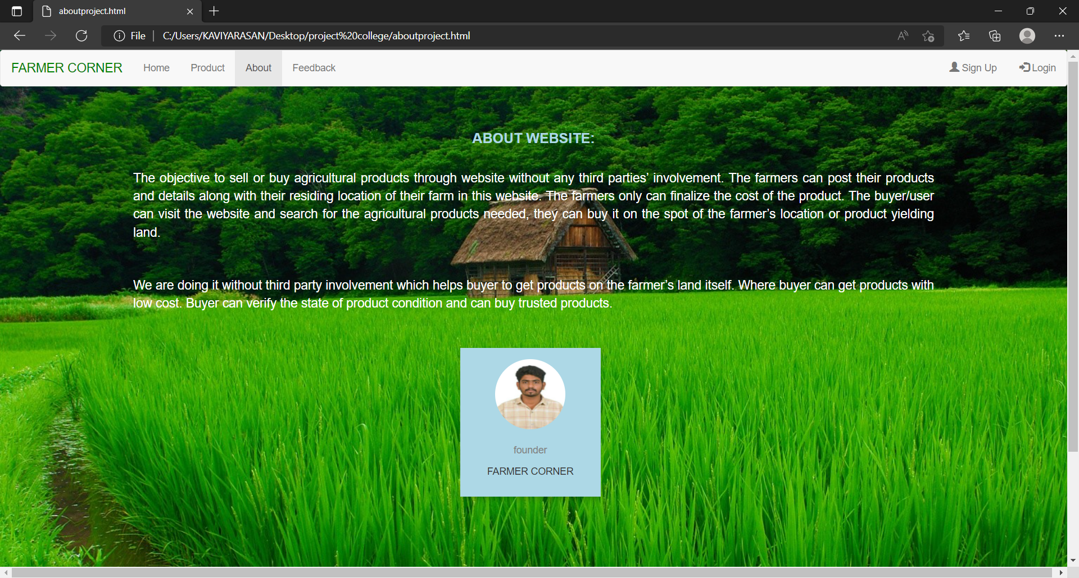

**FEEDBACK FORM**

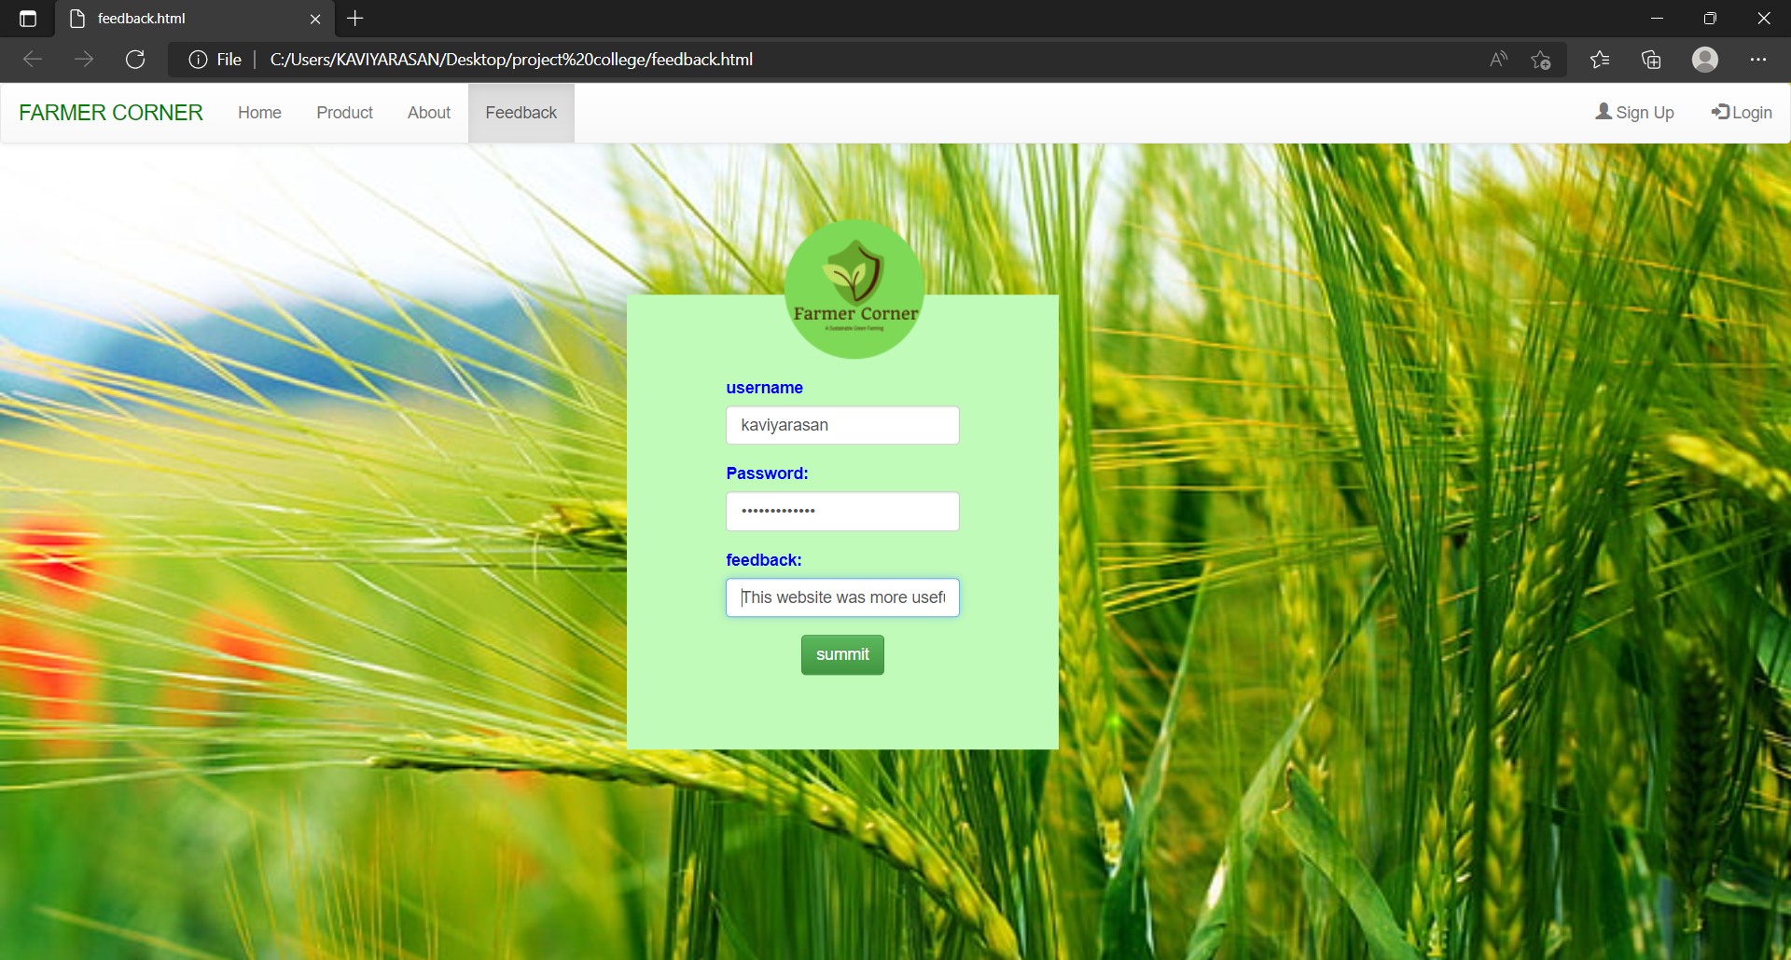

**REGISTERATION**

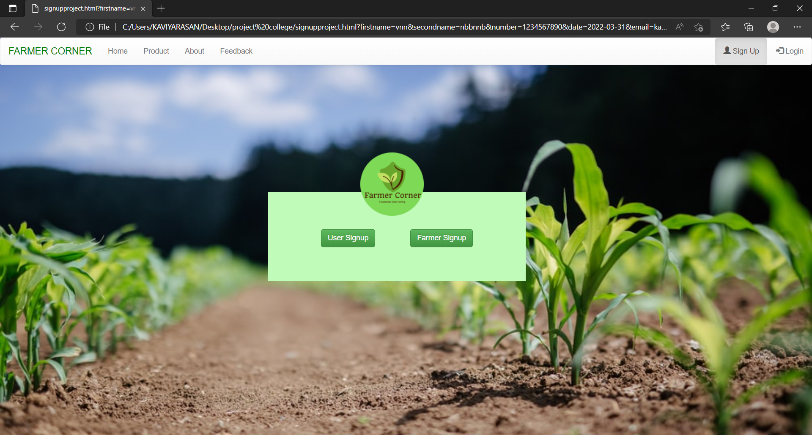

**USER REGISTERATION**

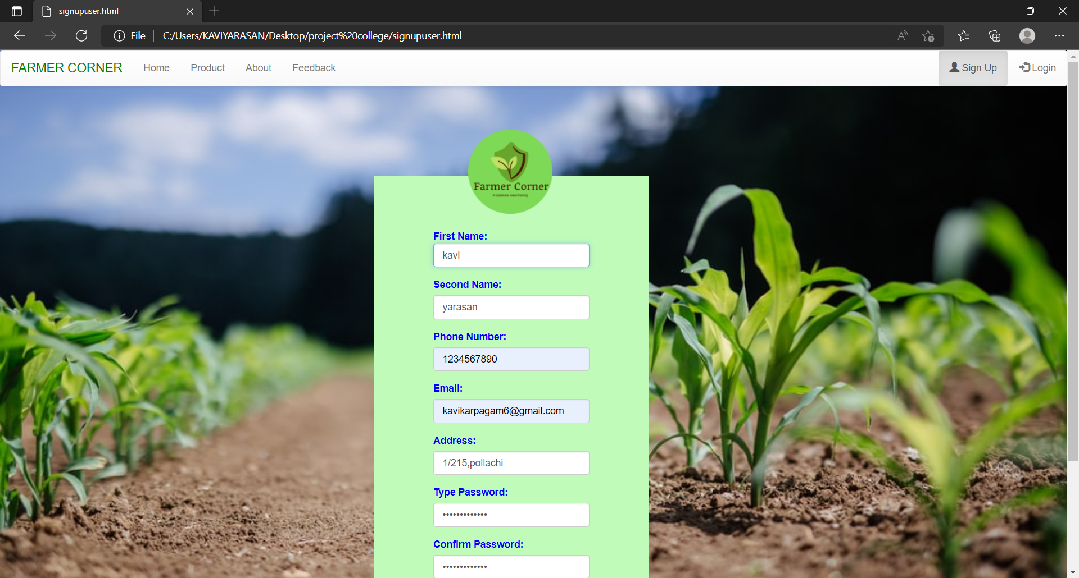

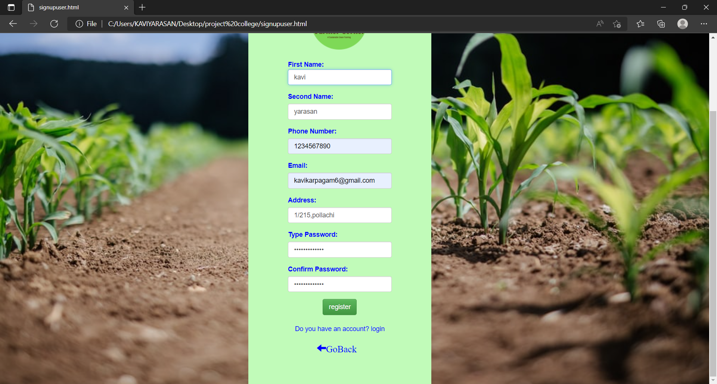

**FARMER REGISTRATION**

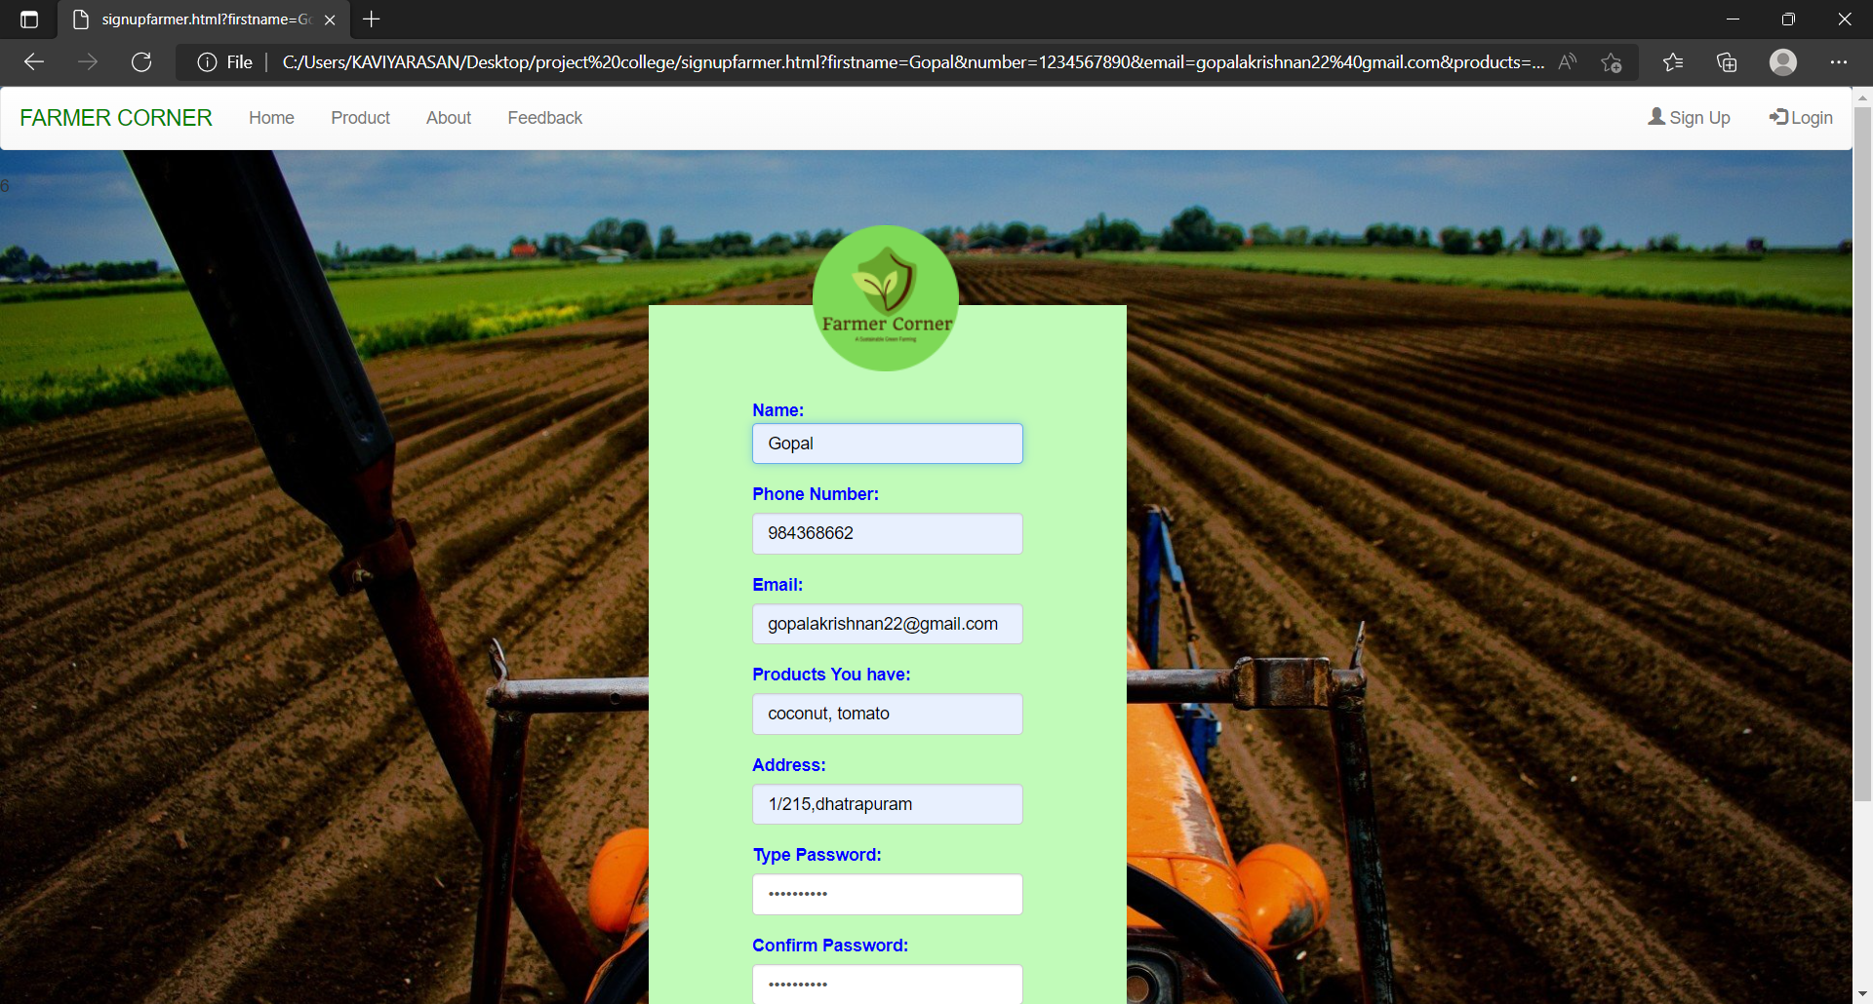

**LOGIN**

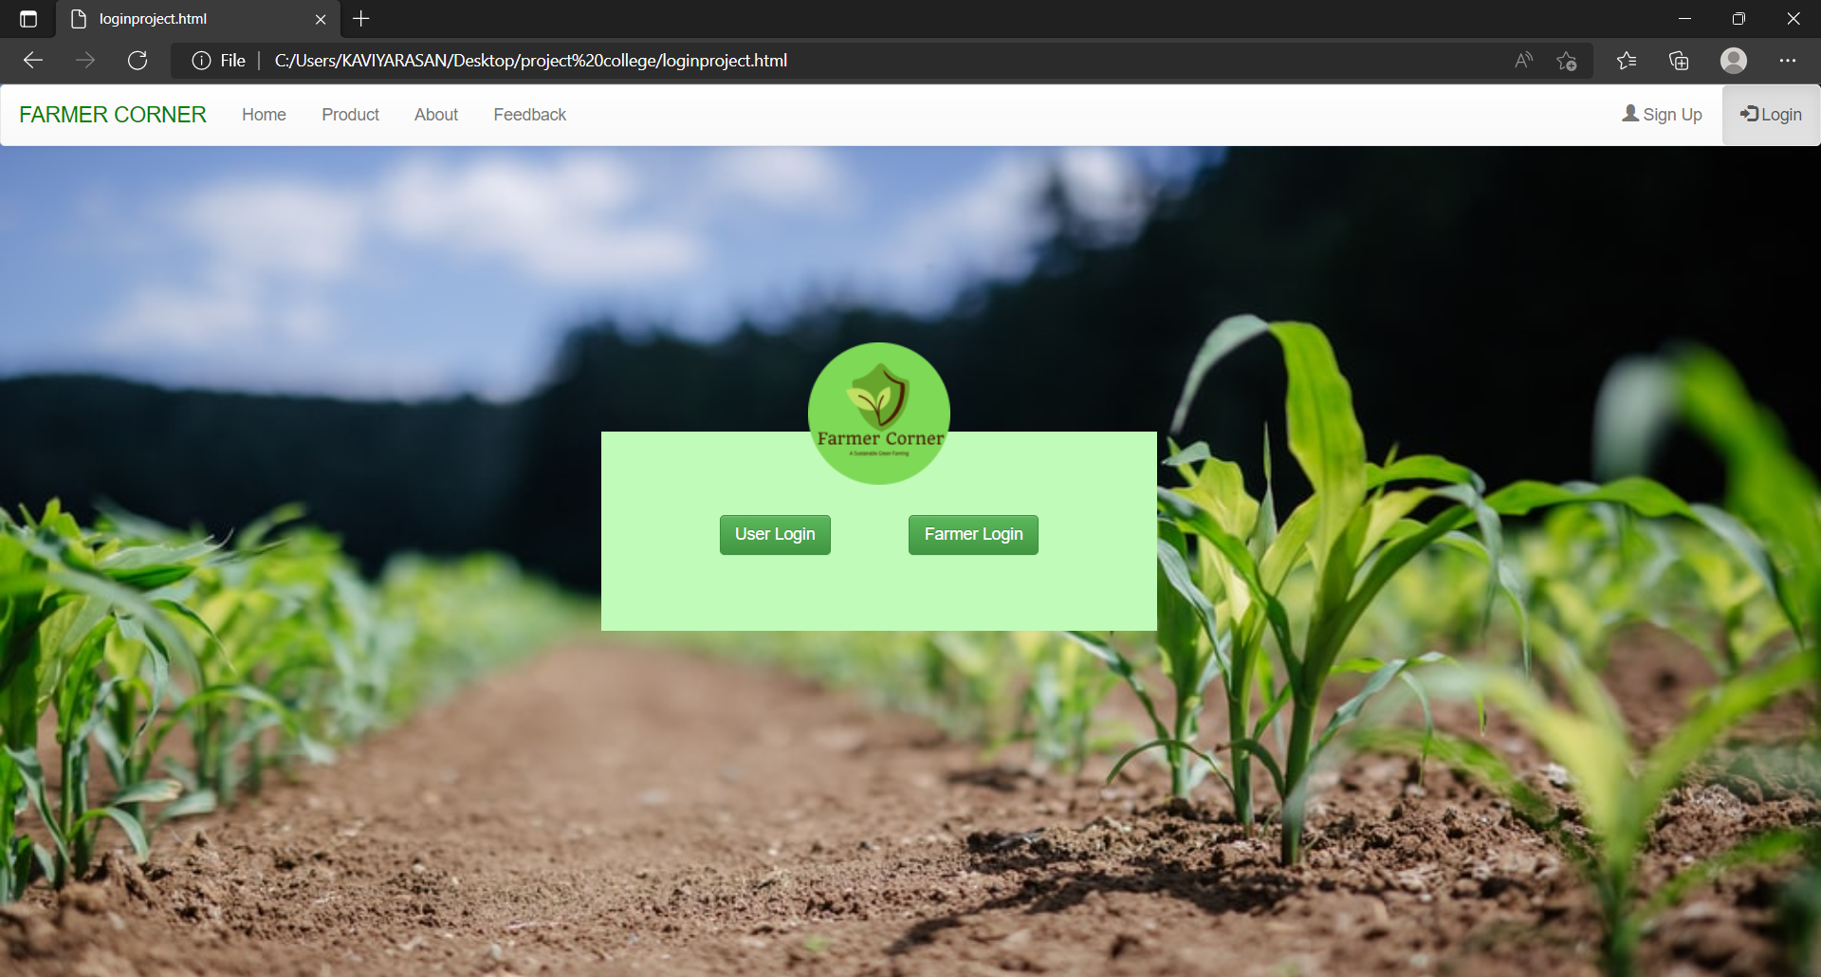

**FARMER LOGIN**

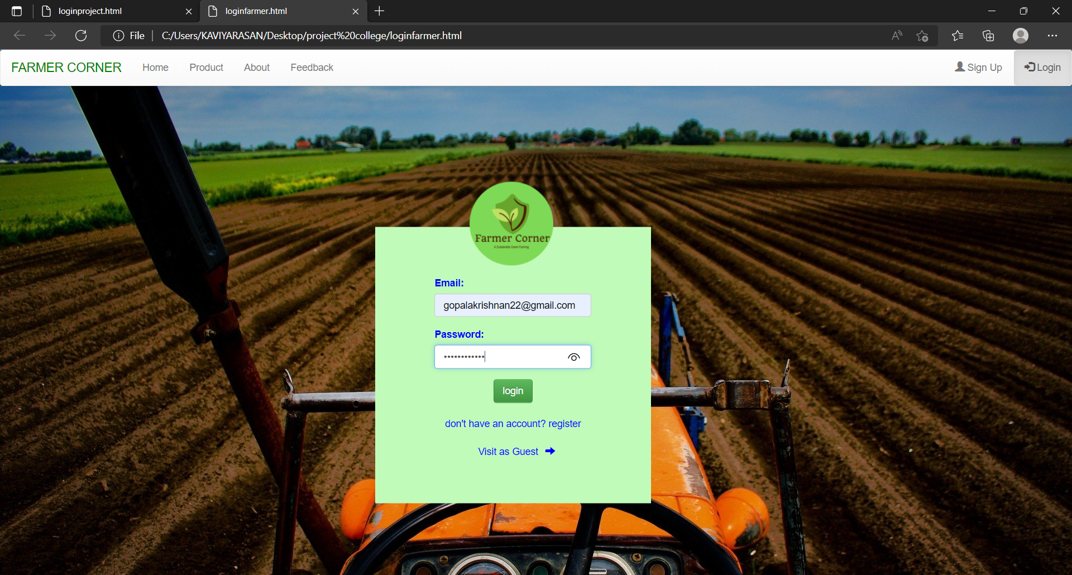

**USER LOGIN**

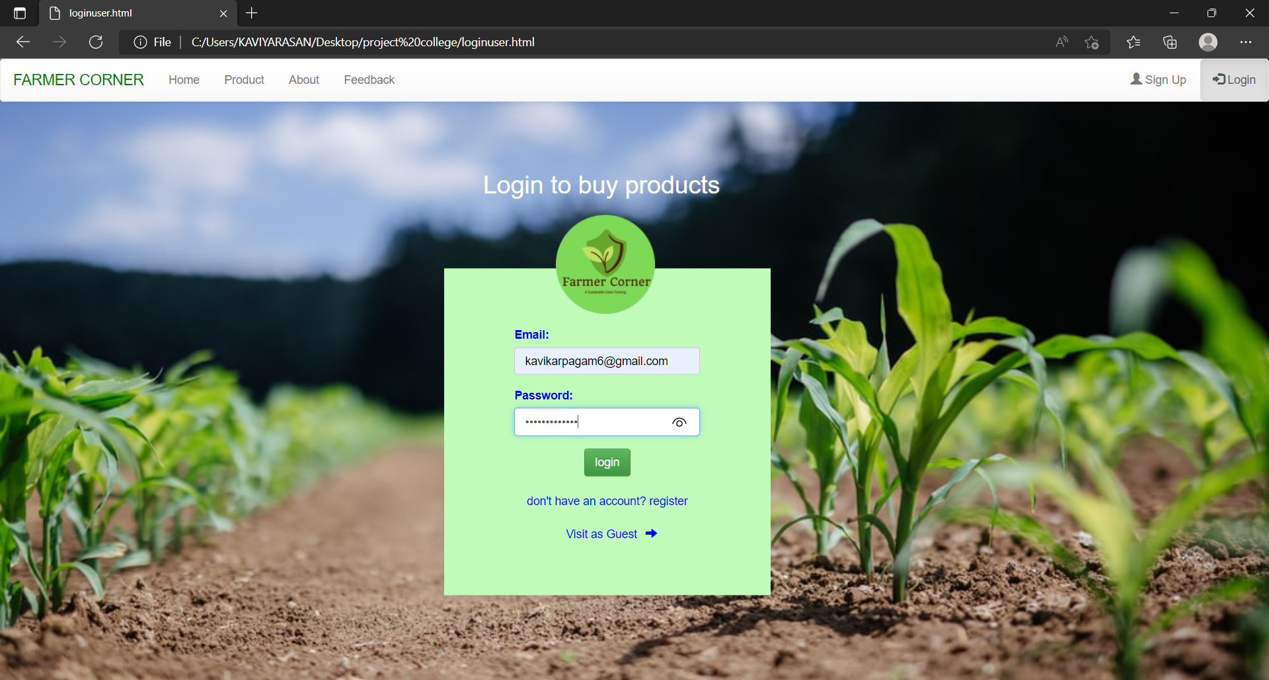

**PARTICULAR ITEM**

